**SOLUTIONS TO CLASS EXERCISE**

***9. Identify and discuss the serious data redundancy problems exhibited by the file structure shown in Figure P1.9. (The file is meant to be used as a teacher class assignment schedule.***

**FIGURE P1.9 The File Structure for Problems 9-10**

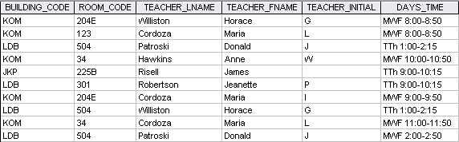

* **Some teacher characteristics occur multiple times in this file.**
* **For example, the teacher named Maria Cordoza’s first name, last name, and initial occur three times.**
* **If changes must be made for any given teacher, those changes must be made multiple times.**
* **All it takes is one incorrect entry or one forgotten change to create data inconsistencies.**
* **Redundant data are not a luxury you can afford in a data environment.**

1. ***Given the file structure shown in Figure P1.9, what problem(s) might you encounter if building KOM were deleted?***

**You would lose all the time assignment allocation data about some teacher/room combinations:**

* + **We will loose the teacher assignments in the KOM building rooms (204E, 123, and 34) for Williston, Cordoza, and Hawkins.**

**This is, therefore, a good reason for keeping data about specific entities in their own tables!**

***(This kind of problem is avoided if our database systems are designed properly)***